|  |
| --- |
| C:\Documents and Settings\Mohammad Alzubaidi\My Documents\YU\logo2.jpg  **Yarmouk University**  **Hijjawi Faculty for Engineering Technology**  **Department of <…………> Engineering**  **Graduation Project Report**  **Electronic Prescribing**  **Osama Haddad 2019980022**  **Dr. Mahmoud Masadeh**  **Semester: second 2024**  **Date: April 2024** |

# Students' Property Right Declaration and Anti-Plagiarism Statement

We hereby declare that the work in this graduation project at Yarmouk University is our own except for quotations and summaries which have been duly acknowledged. This work has not been accepted for any degree and is not concurrently submitted for award of other degrees. It is the sole property of Yarmouk University, and it is protected under the intellectual property right laws and conventions.

We hereby declare that this report is our own work except from properly referenced quotations and contains no plagiarism.

We have read and understood the school's rules on assessment offences, which are available in the Yarmouk University Handbook.

|  |  |  |
| --- | --- | --- |
| **Students:** | |  |
| Name: _________________ | Signature: _______________ | Date: __________________ |
| Name: _________________ | Signature: _______________ | Date: __________________ |
| Name: _________________ | Signature: _______________ | Date: __________________ |
| Name: _________________ | Signature: _______________ | Date: __________________ |

|  |  |  |
| --- | --- | --- |
|  | |  |
|  |  |  |

Table of Contents

Students' Property Right Declaration and Anti-Plagiarism Statement 1

List of Tables 3

List of Figures 4

Abstract 5

Chapter 1: Introduction 1

Chapter 2: Background 4

Chapter 3: Design 6

Chapter 4: Implementation 19

Chapter 5: Results and Discussion 22

Chapter 6: Economical, Ethic, and Contemporary Issues 29

Chapter 7: Project Management 30

Chapter 8: Conclusion and Future Work 31

References 32

# List of Tables

Table 1: Users …………………………………………………………………………………………13

Table 2: Patient descriptions …………………………………………………………………………...13

Table 3: Medicines……………………………………………………………………………………...13

Table 4: Patient medicines …………………………………………………………………………….14

Table 5: Pharmacy branches …………………………………………………………………………...14

Table 6: Pharmacy medicines …………………………………………………………………………14

Table 7: Pharmacies…….………………………………………………………………………….......15

Table 8: Design considerations ……………………………………………………………………….18

Table 9: Time Management ….……………………………………………………………………….30

# List of Figures

Figure1: Workflow………………………………………………………………………………………3

Figure2: Use case diagram……………………………………………………………………………....8

Figure3: Sequence diagram……………………………………………………………………………...9

Figure4: Login interface………………………………………………………………………………....9

Figure5: Registration interface………………………………………………………………………….10

Figure6: Patient interface……………………………………………………………………………….10

Figure7: Physician interface…………………………………………………………………………….11

Figure8: Pharmacist interface………………………………………………………………………......11

Figure9: Admin interface……………………………………………………………………….............12

Figure10: Database schema…………………………………………………………………………….12

Figure11: Process……………………………………………………………………………………….15

Figure12: Add Patient Description…………………………………………………………………….22

Figure13: Interface of Patient Description……………………………………………………………...22

Figure14: Physician Manage Users…………………………………………………………………….23

Figure15: Edit Patient Description …………………………………………………………………......23

Figure16: Pharmacies…………………………………………………………………………………...24

Figure17: Add Pharmacy Branch ………………………………………………………………………24

Figure18: Pharmacy Branches…………………………………………………………………….........24

Figure19: Add Medicine………………………………………………………………..........................25

Figure20: Medicines …………………………………………………………………………………...25

Figure21: Add Pharmacy Medicine…………………………………………………………………….26

Figure22: Pharmacy Medicines ………………………………………………………..........................26

Figure23: Patient Description View……………………………………………………………………27

Figure24: Patient Description Details ………………………………………………………………….27

# Abstract

Electronic Prescribingis a computer-based electronic generation, transmission, and filling of a medical prescription, taking the place of paper and faxed prescriptions. The goal of the system was to provide convenience and choice to patients while improving PBS (Pharmaceutical Benefits Scheme) efficiency, compliance, and drug safety, reduce medical errors, eliminate handwriting interpretation errors.

The system was created to be used bydoctors, pharmacists and maybe the patient to see his/her data or information. The system was created to be availableon the Hospitals and Pharmacies website which always makes the system accessible and anywhere by simply using a web browser and Internet connectivity.

This research project presents the main steps that led to the creation of the system, starting from gathering data about different reporting systems that were available on the Internet and reviewing them. Then, specifying the requirements using Use Case analysis method that was needed to accomplish the design and development phase of the system. The last step was implementing the system.

**Keywords**— It’s a website using: Angular (html), Type script (Java script), MySQL database.

# Chapter 1: Introduction

* 1. problem statement.

When thinking about innovation in the healthcare system, it is almost always medical technology (pharmaceuticals, medical devices, diagnostic and surgical inventions, etc.) that comes to mind. But other aspects of technology support need to move forward as well to provide the most effective processes for both patients and providers. A key aspect of medical technology support lies in health information technology (HIT) systems, which may enable greater cost savings, efficiency, and eventually improved patient outcomes.

Recently, E-Prescribing technology has taken hold as an advance over hand-written drug treatments orders: E-RX, being one of the earliest adoptions in Computerized Physician Order Entry (CPOE), gained acceptance by certain physicians. Prescribing errors are the largest source of preventable errors in hospitals. E-Prescribing, according to the Institute of Medicine, can reduce the number of errors and indeed impact health outcomes (out hospital).

* 1. Background.

Electronic prescribing is an alternative to paper prescriptions, providing patients with convenient access to their medicines, and improving safety by reducing the risk of transcription errors. Electronic prescriptions are not mandatory, and patients will have a choice to receive either an electronic or a paper prescription (but not both). It provides a secure, fast, and efficient supply of medicines via their doctor or telehealth consultation sent directly to the patient’s mobile phone or email. Electronic prescriptions are available nationally as a ‘token’ (via SMS or email) or can be added to an Active Script List (ASL: is a solution that Patients will need to register for an Active Script List by visiting a pharmacy that is enabled to offer this service.). To generate an electronic prescription, you will need the capability built into your clinical information system.

* 1. Aims and objectives.

our aim in this project is to develop a user-friendly web application framework that allows physicians and other medical practitioners to write and send prescriptions to a participating pharmacy electronically instead of using handwritten or faxed notes or calling in prescriptions.

* 1. What is your main solution idea?

The goal of implementing e-prescribing was to achieve the following:

1-reduce medical errors, decrease pharmacy costs, improve both prescriber and pharmacy efficiency, eliminate handwriting interpretation errors, reduce phone calls between pharmacists and physicians, reduce data entry, and expedite prescription refill requests.

2- A systematic aim which helps in intervening and preventing drug therapy problem by creating a system that make communication efficient between doctor and the pharmacist(dispenser) explicit and precise and leaves reference when needed and to ensure patient safety by administering effective therapy.

* 1. A list of contributions with short descriptions that you can claim from your work.

• Patient safety.

• Prescribing efficiency.

• Improved customer service.

• Cost savings.

• Instant notifications of allergies, drug interactions, duplicate therapies.

• Prevent prescription drug errors.

• Easily prescribe controlled substances.

• Monitor controlled substance prescriptions.

• Reconcile medication history quickly.

• Meet meaningful use requirements.

• Easily track prescription fulfillment.

• Reduce lost prescriptions.

• Pharmacy employees spend less time calling to verify orders.

• Easily prescribe medications that are covered by insurance.

* 1. Provide a high-level figure of your workflow.

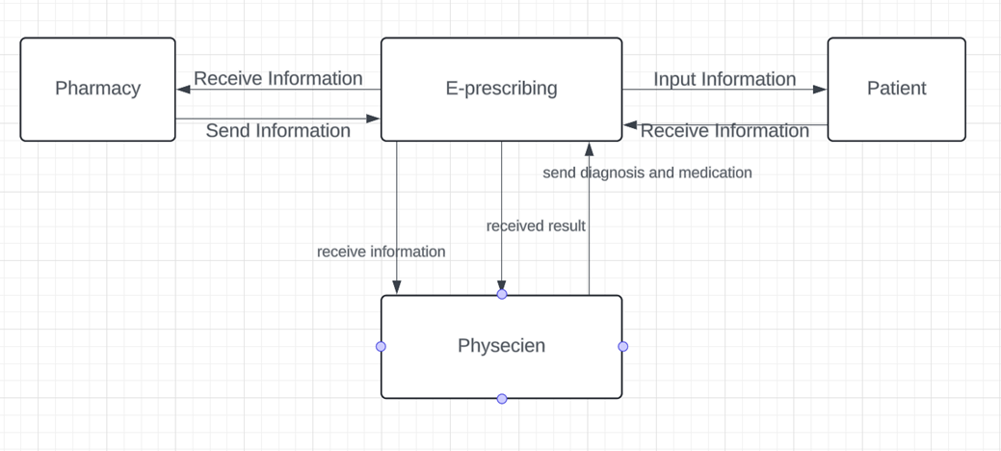

Figure 1(workflow)

The patient goes to the doctor to diagnose his condition, so he enters his information via the website (e-prescribing) and knows what his symptoms are. On this basis, the doctor sends records including diagnosis and medication patient’s file electronically. After that, this file is sent to the pharmacy to give the patient the medicines with what doses to take, and all of this is recorded in the patient’s file electronically.

* 1. Summary of report structure.

The findings of this project study suggest that e-prescribing has the potential to increase patient safety and patient medication adherence; create cost savings for medical clinics, hospitals, and patients; and improve efficiency in the ambulatory care setting. E-prescribing also ensures that patients receive medication on time and reduces errors due to illegible handwriting.

# Chapter 2: Background

* 1. background of the problem.

When thinking about innovation in the healthcare system, it is almost always medical technology (pharmaceuticals, medical devices, diagnostic and surgical inventions, etc.) that comes to mind. But other aspects of technology support need to move forward as well to provide the most effective processes for both patients and providers. A key aspect of medical technology support lies in health information technology (HIT) systems, which may enable greater cost savings, efficiency, and eventually improved patient outcomes.

Recently, E-Prescribing technology has taken hold as an advance over hand-written drug treatments orders: E-RX, being one of the earliest adoptions in Computerized Physician Order Entry (CPOE), gained acceptance by certain physicians. Prescribing errors are the largest source of preventable errors in hospitals. E-Prescribing, according to the Institute of Medicine, can reduce the number of errors and indeed impact health outcomes (out hospital).

* 1. Target market and their needs.

-Efficiency: healthcare providers and pharmacies seek to simple the workflow and reduce the burdens associates with the traditional paper description process the electronic prescribing system can completing the process of creating and transporting prescriptions which saves time and resources for all parties.

-Patient safety: the electronic prescribing system helps to reduce the risk of drug errors, such as unread writing and the different quantities requires by providing electronic access at any time to patient drug records which enhances the patient safety system and reduces the possibility of adverse drug events.

* 1. Potential ethical and/or environmental issues.

1. Data privacy is one of the potential ethical concerns in a project.
2. Paper reduction: by eliminating paper prescriptions when health care providers and pharmacies significantly reduce the use of paper and thus increase the conservation of natural resources and reduce waste.
   1. Summarize the different approaches currently/previously used to solve the problem.

* The system works to transfer prescriptions electronically from all parties to health care, which eliminates the need for paper prescriptions, as well as the creation, transfer and tracking of prescriptions electronically leads to increased accuracy and safety of patients.
* Enabling the safe exchange of patient health information, including prescriptions between different health care institutions, and this facilitates communication solutions and data exchange between doctors and pharmacies and patients in the field of health care.

# Chapter 3: Design

* 1. Design Overview:
     1. Describe the design of your project to achieve the solution.

In designing and implementing electronic prescriptions, the requirements of all stakeholder groups (such as pharmacists, physicians, and patients) must be carefully considered. In case of responding to user needs, the electronic prescription can improve the medication prescription process since users prefer the electronic prescription system that meets their professional needs. Physicians are the main users of the electronic prescription system and considering their clinical needs and priorities is essential for developing the National Electronic Prescription System.

- Angular(html):

Angular is a platform and framework for building single-page client applications using HTML and Typescript. Angular is written in Typescript. It implements core and optional functionality as a set of Typescript libraries that you import into your applications, Each Angular template in your application is a section of HTML to include as a part of the page that the browser displays. An Angular HTML template renders a view, or user interface, in the browser, just like regular HTML, but with a lot more functionality. Angular Ng Modules differ from and complement JavaScript.

- Type Script (java script):

Typescript is a strongly typed programming language that builds on JavaScript, giving you better tooling at any scale. Typescript adds additional syntax to JavaScript to support a tighter integration with your editor. Catch errors early in your editor, Typescript code converts to JavaScript, which runs anywhere JavaScript runs: In a browser, Typescript understands JavaScript and uses type inference to give you great tooling without additional code.

* Database Management (MySQL):

Facilitates efficient retrieval and management of relevant information, since MySQL is open source, it includes numerous features developed in close cooperation with users. MySQL is fast, reliable, scalable, and easy to use.

* + 1. How do you plan to address the problem statement.
* The user (patient) enters the system by his username and password he can see the description that doctor writes to him.
* The user (physician) entered to system by his /her (username, password) and reach to patient information by his /her username, to checked if he has record or this is first time if it’s the first time he can add the patient information.
* In briefly write all the information about his/her what the patient suffers from.
* Writing the prescription according to what is customary, so that it is matched with the pharmacy stock that is to be selected later.
* The user will be to:
* Determinate the pharmacy dependent on the address if the patient wanted.
* Check if the prescription is available at the pharmacy by matching its database with the available medicines. If it is not available, the doctor has the option to go back to the previous one, either by changing the pharmacy or writing an alternative treatment.
* Now after all of this make submitted.
* After this the Pharmacist script to insurance company for adjudication.
* Then submitted to insurance company for approval from them.
* Then they get the approval for the script, finally the payment is collected, and the drug is dispensed to the patient.
  + 1. Provide a detailed figure of your solution, describing the interaction between the components in detail. Describe one or two scenarios of how the end users will use your solution/system.

Use case diagram:

Figure 2 (Use Case diagram)

Sequence diagram:

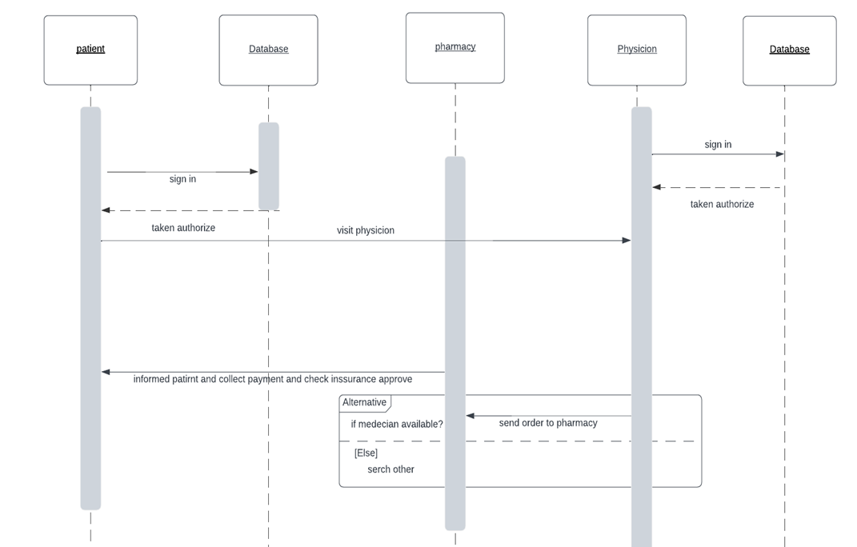

Figure 3 (Sequence diagram)

Description:

• User interface:

1. log into the system.

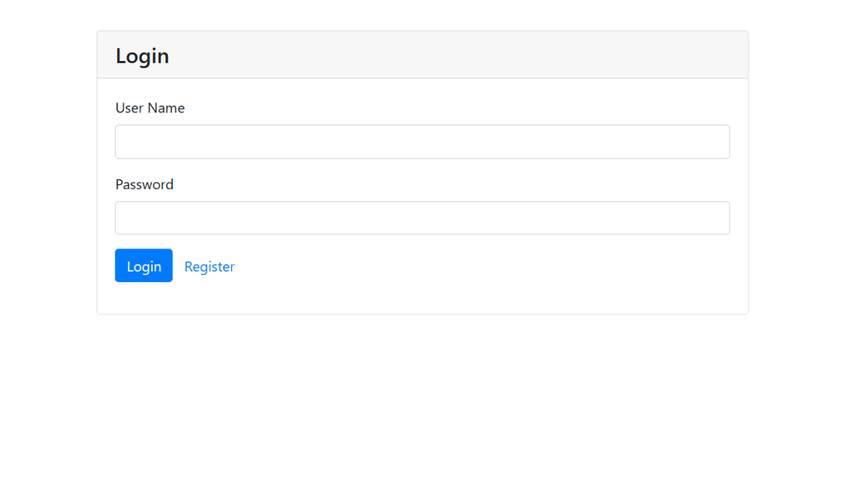

Figure 4 (Login Interface)

1. The user interacts with the web interface, where they can login with username and password and if not exist choose registration to be a user in the system.

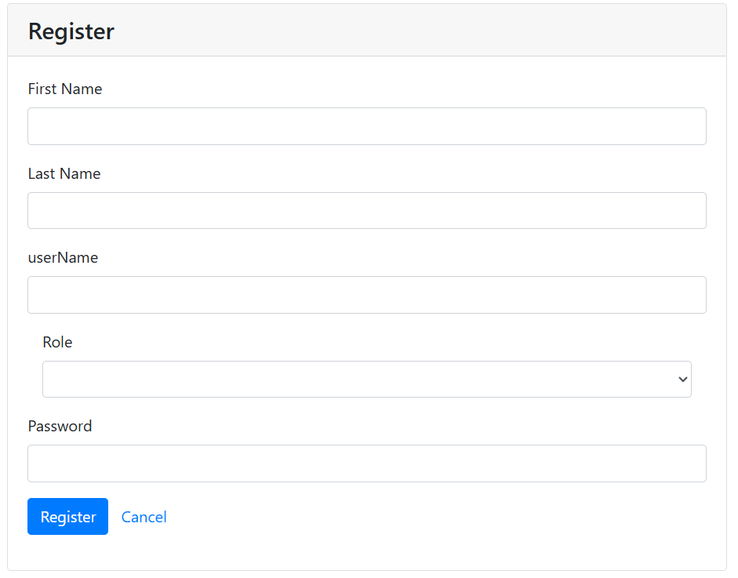

Figure 5 (Registration Interface)

3. If the user is patient, then the interface of him will display and he can view patient description and logout.

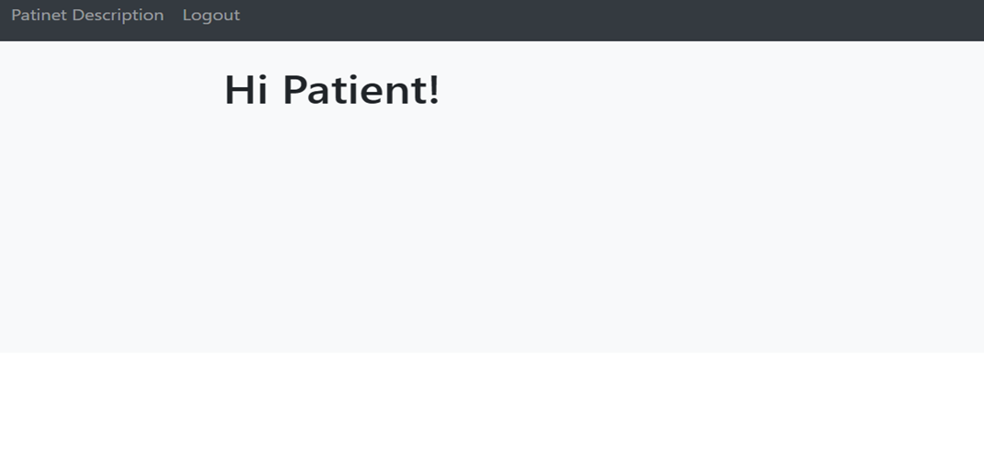

Figure 6 (Patient Interface)

4. If the user is physician, then the interface of him will display and he can view patient description and add patient description, manage users and logout.

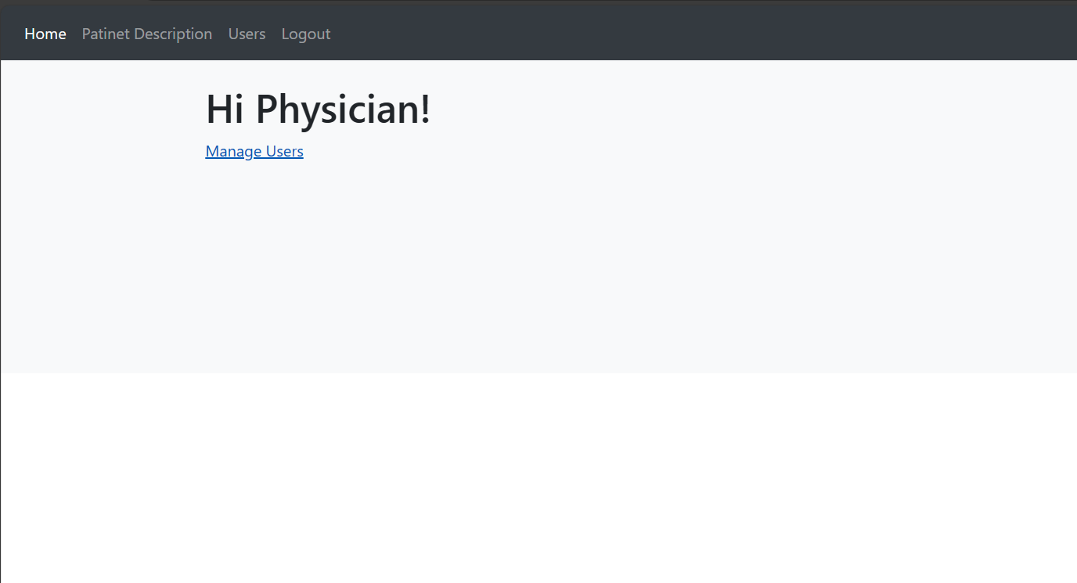

Figure 7 (physician Interface)

5. If the user is pharmacist, then the interface of him will display and he can view patient description and add patient description, add pharmacy, view pharmacies, add branch to pharmacy, add medicines, view medicines, add medicine to pharmacy and logout.

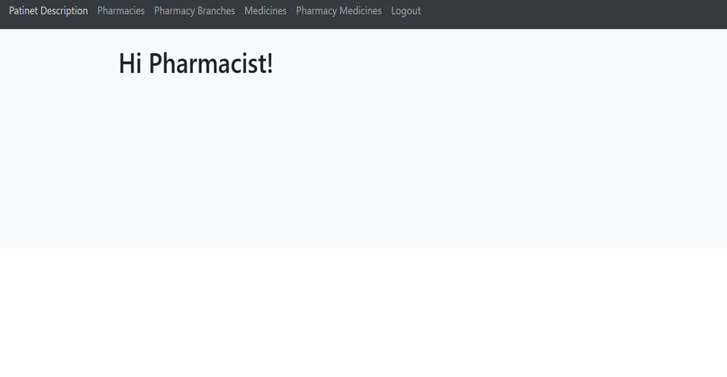

Figure 8 (Pharmacist Interface)

6. If the user is an admin, then the interface of him will display and he can manage all methods and information and users in the system.

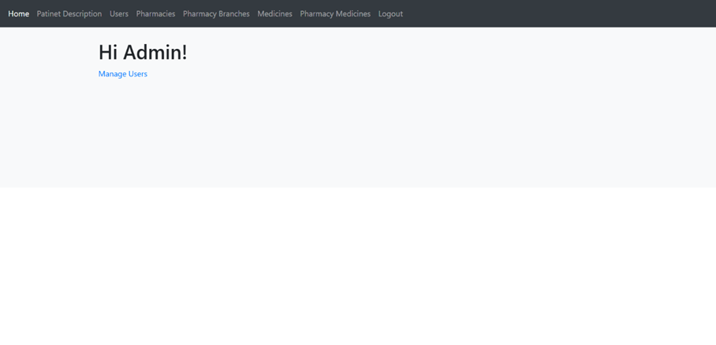

Figure 9 (Admin Interface)

Backend Server:

Management database CREATE, READ, UPDATE and DELETE (CRUD).

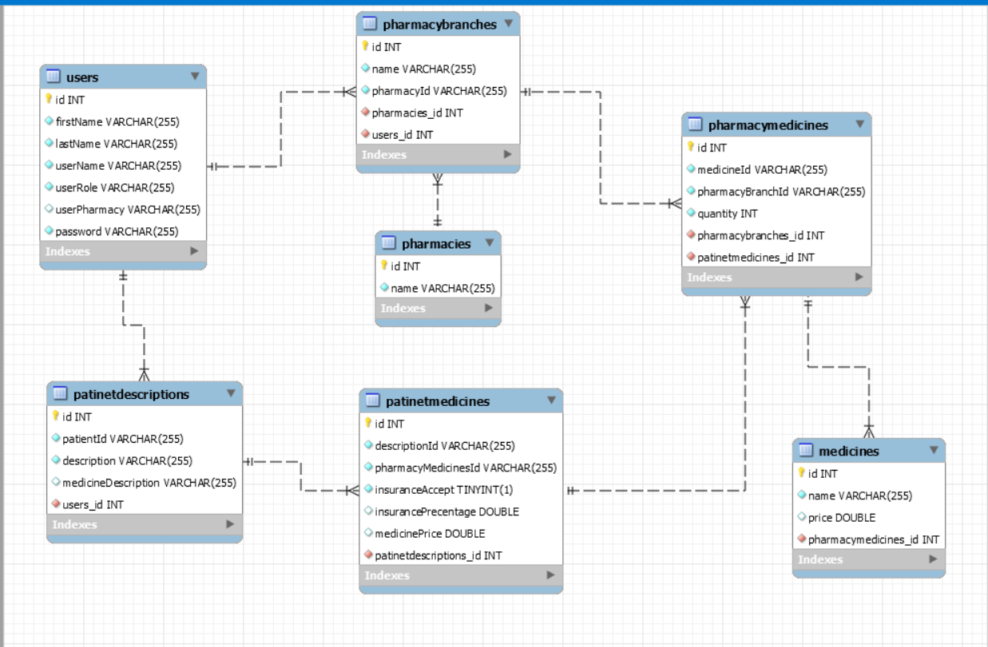

Figure 10 (Database schema)

1. Users Table: this table saves all information about the users such as username, password, first name, last name, user role (physician, patient, pharmacist, administrator), user pharmacy.

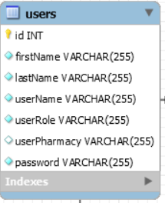

Table 1: (users table)

1. Patient Description Table: this table shows all patients descriptions from the id.

Table 2: (Patient Description table)

1. Medicines Table: this table shows all medicines in pharmacies.

Table 3: (Medicines table)

1. Patient Medicines Table: this table shows the medicines of the patients from the descriptions of them and if the patients have the insurance or not.

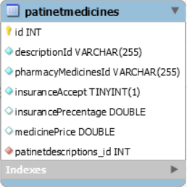

Table 4: (Patient medicines table)

1. Pharmacy Branches Table: this table shows all pharmacies branches from specific pharmacy.

Table 5: (Pharmacy Branches table)

1. Pharmacy Medicines Table: this table shows all medicines in the pharmacy and the quantity of these medicines.

Table 6: (Pharmacy Medicines table)

1. Pharmacies Table: this table shows all pharmacies in the system.

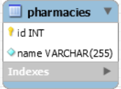

Table 7: (Pharmacies table)

* 1. Design Details:
     1. Design Specifications

Our estimation is that the project will take approximately 3 months to complete. Once the project is finished, the website will be fully operational and accessible to anyone who wishes to use it. The interface is user-friendly, clear, and simple to navigate, which makes it suitable for all members of society. Moreover, the system will directly benefit the users, making it highly likely to achieve great success.

* + 1. Design Process
* We will use Angular, CSS, and Java Script to design easy to use user interface.
* Backend Processing (MySQL): it’s responsible for the all-database operations(crud).

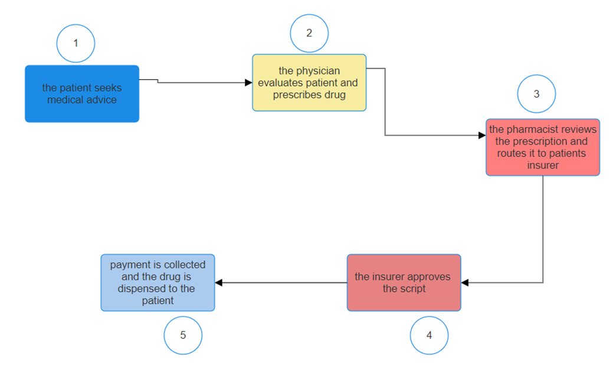

Figure 11: (process)

Functional requirements:

1. User Authentication and Authorization:

-Users should be able to log in securely using their credentials (username/password)

- Different roles should be defined (e.g., doctor, pharmacist) with varying levels of access rights and permissions.

2. Patient Management:

- Healthcare professionals should be able to search for and select patients from a database.

- The system should display patient description.

3. Prescription Creation:

- Healthcare professionals should be able to create new prescriptions for patients.

- The system should provide fields for entering medication details including name, dosage, frequency, route of administration, and duration.

- Prescription forms should support the addition of multiple medications if necessary.

- Prescription forms should include fields for specifying patient instructions and additional notes.

4. Medication Database Integration:

- The system should integrate with a medication database/API to provide autocomplete suggestions and ensure accurate medication selection.

- It should support searching for medications by name, class, or other criteria.

5. Prescription Verification and Approval:

- Prescriptions should be sent to the appropriate healthcare professionals (e.g., another doctor for approval or a pharmacist for dispensing).

- The system should allow for verification and approval of prescriptions by authorized personnel.

- Once approved, prescriptions should be marked as finalized and ready for dispensing.

6. Prescription Management:

- Authorized users should be able to view, edit, and delete prescriptions.

- The system should support archiving old prescriptions for record-keeping purposes.

- Users should be able to search for prescriptions based on patient details, medication name, date, etc.

7. Interaction Checking:

- The system should perform checks for potential drug interactions based on the medications prescribed.

- It should alert users to potential interactions and provide recommendations for alternative medications if necessary.

Nonfunctional requirements:

1-Accessibility: our system can be accessed anytime anywhere to physician, patient, Pharmacist Capacity, current and forecast: our system can be acceptable to any capacity because we will use Hybrid HIE Architecture.

2-Documentation: we print all information as documentation and save it as a soft copy if we need it to understand what is done and what the workflow is followed, and we can show that’s in folder hospital to any patient.

3-Efficiency, Effectiveness: we provide both in reduce time, cost, flexibility.

4-Quality: our system improves quality throw reduce medical error form any error comes from Handwritten Prescription.

5-Response time: because of the use of Hybrid HIE Architecture the response time was done in short time.

* + 1. Legal Aspects

Ensure that the system maintains the patient’s privacy and maintains the patient’s medical history and private data. The intellectual property rights of the original owner of the idea and his research must be preserved.

* + 1. Design Constraints

• Use JavaScript, HTML as programming languages and MYSQL for database.

• The system is available every time.

* + 1. Design Standards

Designing an easy-to-use user interface, verifying the validity of the system and that it works correctly and efficiently, ensuring that this system protects patient privacy.

* + 1. Design Alternatives

The design can be modified to allow users to use it from the phone with ease.

* + 1. Safety Consideration

such as data backup and recovery, periodic test, secure design, and regular update.

* + 1. Design considerations table.

|  |  |  |
| --- | --- | --- |
| Design consideration | Project application | Relevant location in report |
| Performance | In designing and implementing electronic prescriptions, the requirements of all stakeholder groups | Section 3.2.1 Design Specification |
| Serviceability | Web application interface | Section 3.1.3  Section 3.2.2 |
| Economic | Cost-effective development and maintenance | Section 3.2.1 Design Specification |
| Environmental | The system compatible with the specific platform it will be running on | Section 3.2.1 Design Specification |
| Environmental Sustainability | Using efficient algorithms and data structures can help reduce the computational resources required by the application | Section 3.2.1 Design Specification |
| Manufacturability | N/A | N/A |
| Ethical | System provides data protection protocols | Section 3.2.4 |
| Health and safety | Ensuring that sensitive user data is protected from unauthorized access | Section 3.2.7 Safety Consideration |
| Social | User-friendly interface for users | Section 3.2.1 Design Specifications |
| Political | Compliance with healthcare data protection laws | Section 3.2.3 Legal Aspects |

# Chapter 4: Implementation

* 1. Give a precise description of the methods and tools (hardware, software … etc.) used to implement your solution.

- Software:

1- Visual Studio Code: Used as the Integrated Development Environment (IDE) for coding and managing the project.

2- Angular: Employed in front-end development, offering features like two-way data binding and dependency injection for building interactive user interfaces.

3- JavaScript: To enhance user interactivity, this script is used in the AngularJS client-side scripting framework.

4- MySQL: used to store and manage prescription data in a secure manner as a back-end database management system.

- Since the solution was primarily based on a software environment, no hardware components were needed to implement it.

* 1. What infrastructure your solution depends on, or is using to accomplish its tasks?

1. Frontend (User Interface):

Angular: is a front-end framework for user interface UI development. Angular provides a structured approach to UI development, offering features such as data binding and component-based architecture that ensures the user experience is dynamic and responsive.

2. Backend:

• JavaScript: Powers the backend functionality of the application, with its versatility and event-driven nature, enables efficient handling of server-side logic, data processing, and integration with the frontend.

• Database: For the storage and management of prescription related data, the solution depends on a robust database system, specifically MySQL. To operate an electronic prescribing system, MySQL ensures data integrity, security, and scale.

3. Communication Protocol:

• HTTP: Enables the system's front and back components to communicate with each other. HTTP (Hypertext Transfer Protocol) enables the exchange of data between the client (frontend) and server (backend), ensuring seamless interaction and data transfer.

* 1. What are the trade-offs that you had to make in your design/implementation?

1. Technology Reliability: Software platforms, connectivity, electronic health records (EHRs), and other technology infrastructure are critical components of e-prescribing systems. Workflows and patient care can be negatively impacted by reliability difficulties such as connectivity failures, software bugs, or system outages.

2. Data Security and Privacy: Sensitive patient data, such as pharmaceutical orders and medical histories, are transmitted electronically as part of e-prescribing. It is crucial to protect the privacy and security of this data to stop misuse, breaches, and illegal access.

3. Workflow Integration: Modifications and integration with current procedures are necessary when e-prescribing is added to clinical workflows. It may be necessary for clinicians to become familiar with new software interfaces, adjust to modifications in prescription procedures, and guarantee smooth communication with pharmacies and other healthcare providers.

4. User Experience: There are a lot of differences in e-prescribing systems' usability and user experience. Clinicians may become frustrated due to poorly designed interfaces, complicated workflows, or insufficient training, which could have an impact on adoption rates and patient care.

* 1. What are the dependencies/assumptions of your implementation?

1.Angular (UI):

- Angular framework is used in the development of the front-end application.

- Requires installation and upkeep of Angular framework libraries and dependencies.

- Reliant on browser compatibility and Angular application support.

2.Backend (JavaScript):

- JavaScript is used to implement the backend server-side logic, with a Node.js runtime environment.

- Needs associated JavaScript libraries and frameworks, as well as Node.js.

- Reliant on the dependencies and runtime environment of Node.js.

3.Database:

- MySQL server is used to implement the database layer so that queries and data manipulation can occur.

- Needs the installation of the MySQL server and any necessary prerequisites.

- Reliant on MySQL schema definitions and database technology.

4.Communication (HTTP):

- HTTP protocol is used for communication between the back end (JavaScript) and front-end (Angular).

- Necessitates handling HTTP requests and responses in both server-side and client-side code.

- Requires network connectivity and appropriate HTTP endpoint configuration

# Chapter 5: Results and Discussion

* 1. Present the results of your work and discuss them in detail and how they are linked to what has been discussed in the design chapter.

**The website has three main branches:**

1- Physician: This section shows how physician interact with system the figures show how the physician can add patients descriptions firstly add the patient name in the box of it then add the patient description then add medicine description, and then select the pharmacy which the closest to the patient and select the medicine name and press to add patent description bottom then press to save bottom to save all the patient description in the system with specific id. Also, the physician can add/show users in the system.

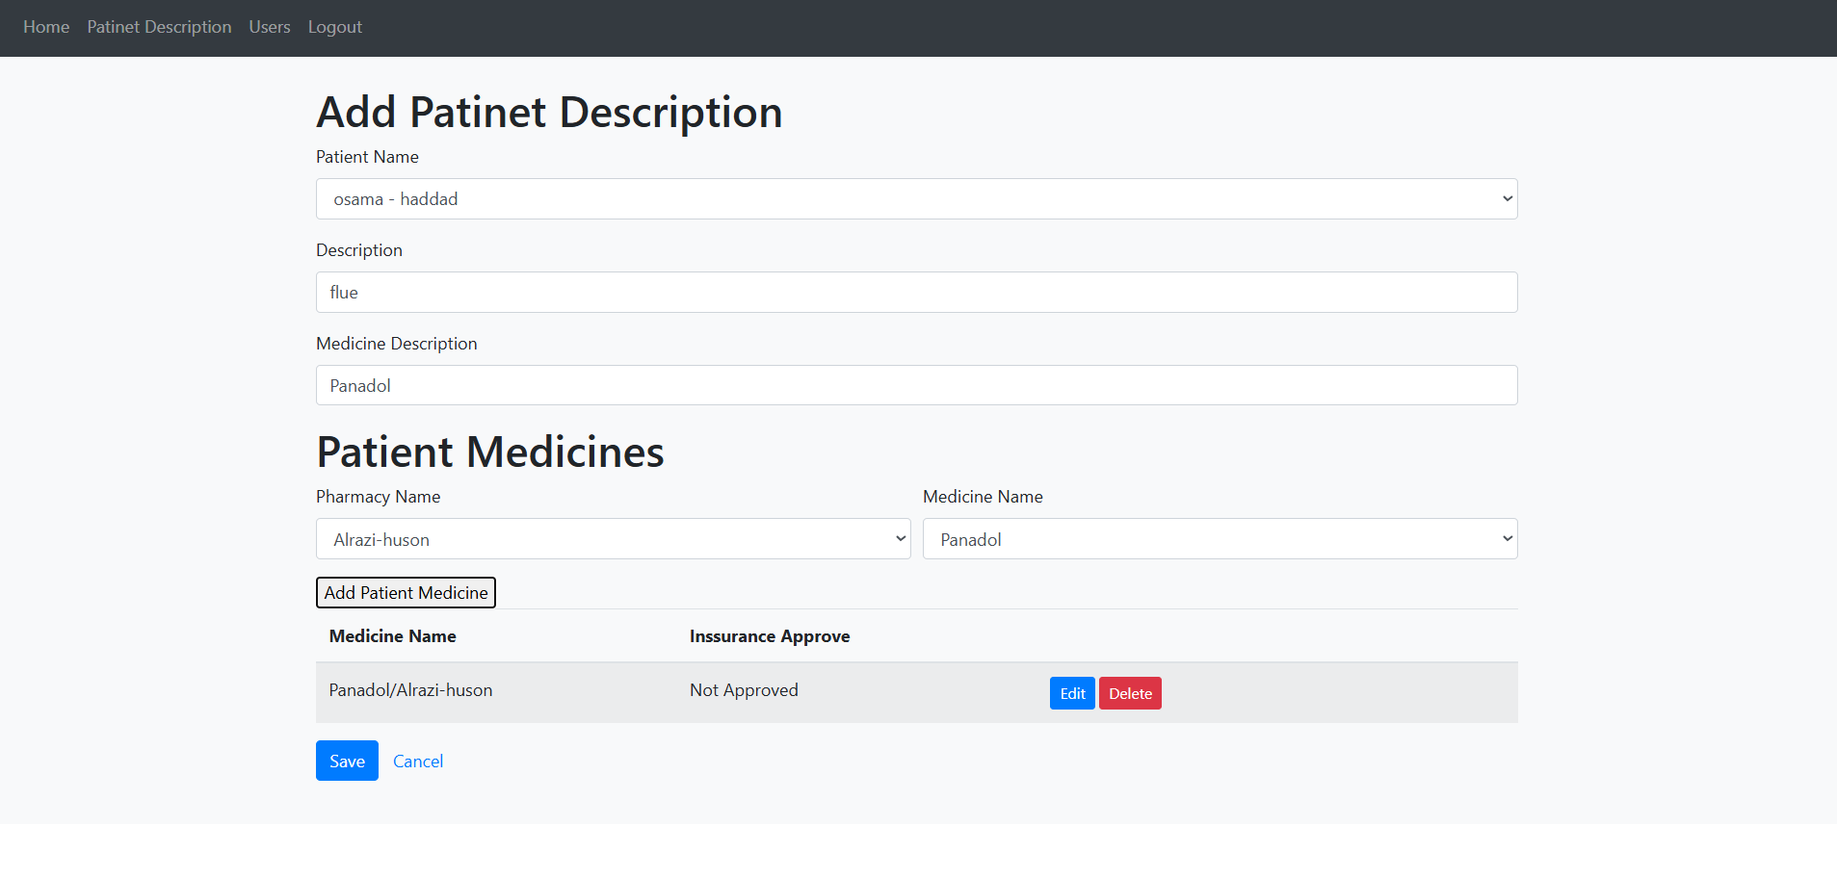

Figure 12: (Add Patient Description)

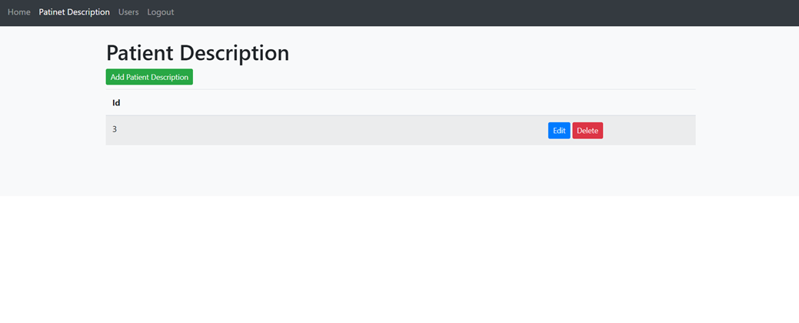

Figure 13: (Interface of Patient Description)

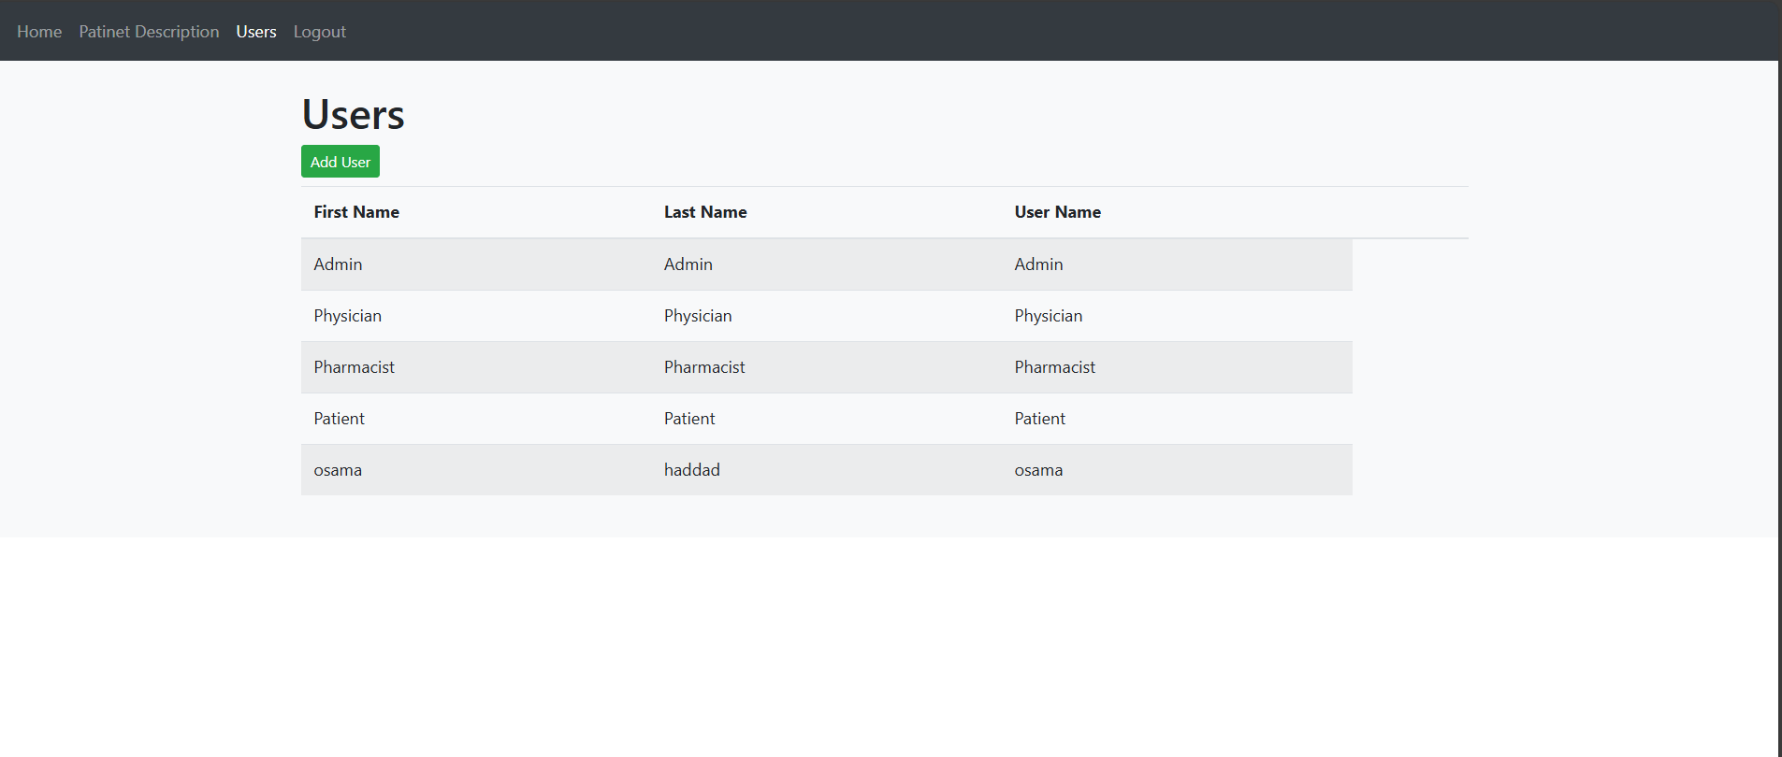

Figure 14: (Physician Manage Users)

2- Pharmacist: This section shows how the pharmacist interacts with system firstly in the patient description the pharmacist open the patient description then checks if the patient has an insurance approve edit the information to approvable from the selected bar then checks what’s the percentage of insurance this is edit auto in the medicine price as show in the figure 15 then click to save bottom and in the page of pharmacies he can add or edit or delete any pharmacy as show in the figure 16 also, in the page of pharmacy branches he can add/delete any branch from the pharmacies in the system like figure 17 I add branch Alrazi in Aqaba also, in the page of medicines the pharmacist adds/deletes any medicines with price, and in the page of pharmacy medicines the pharmacist select specific pharmacy from system and select specific medicine to add the quantity of it as show figure 21 .

Figure 15: (Edit Patient Description)

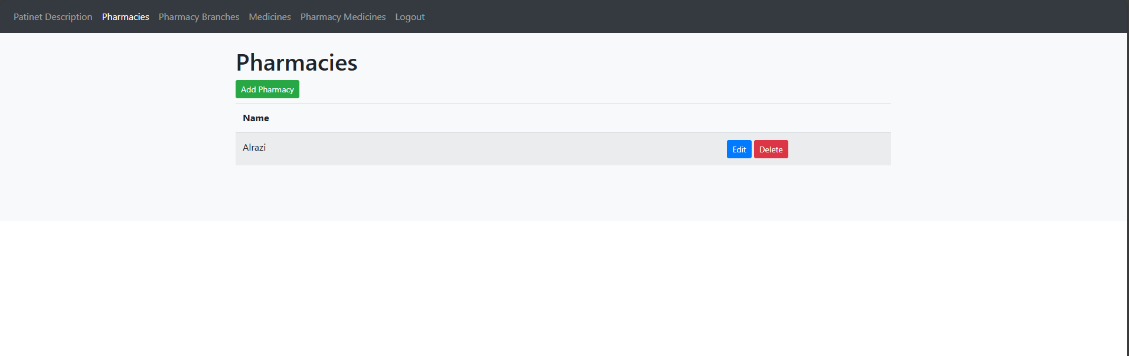

Figure 16: (Pharmacies)

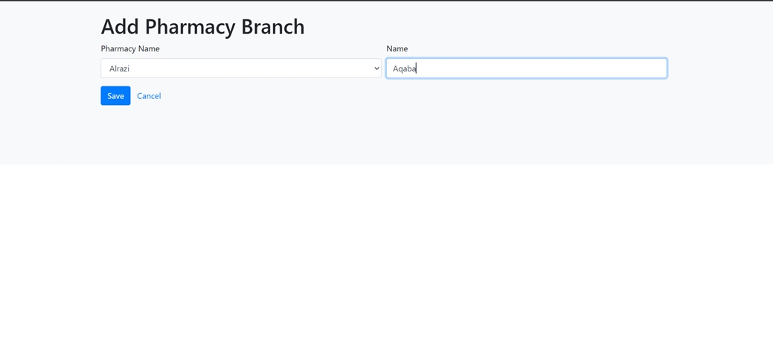

Figure 17: (Add Pharmacy Branch)

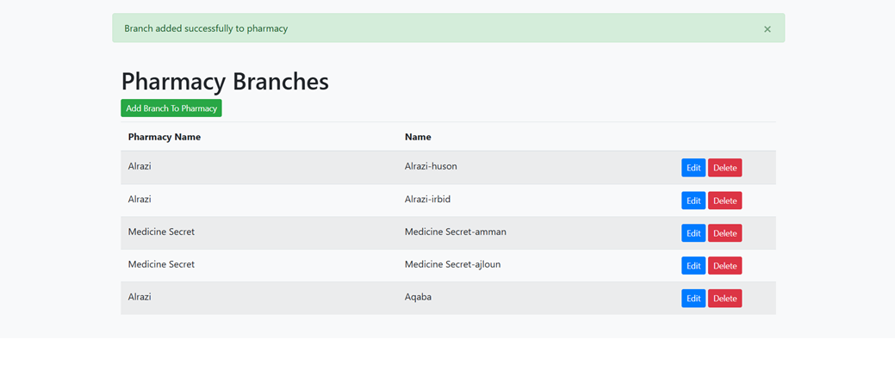

Figure 18: (Pharmacy Branches)

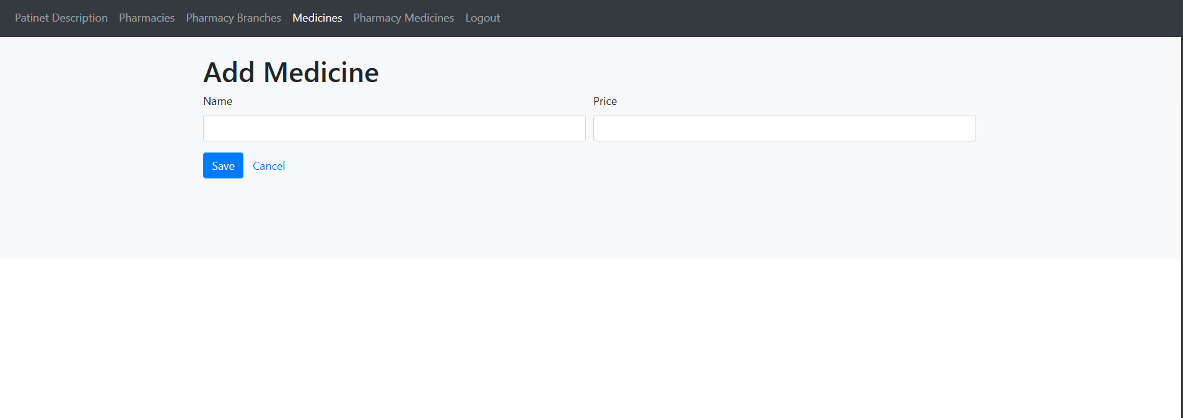

Figure 19: (Add Medicine)

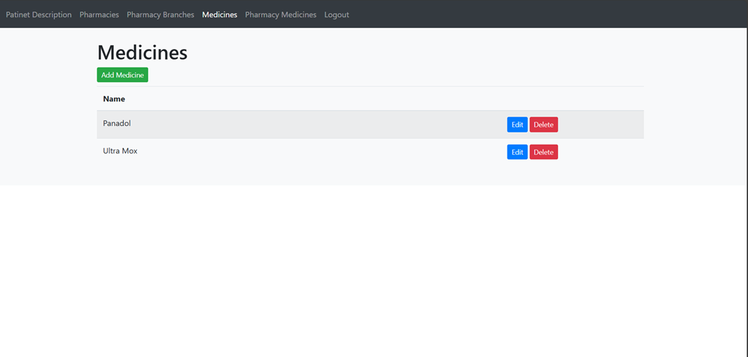

Figure 20: (Medicines)

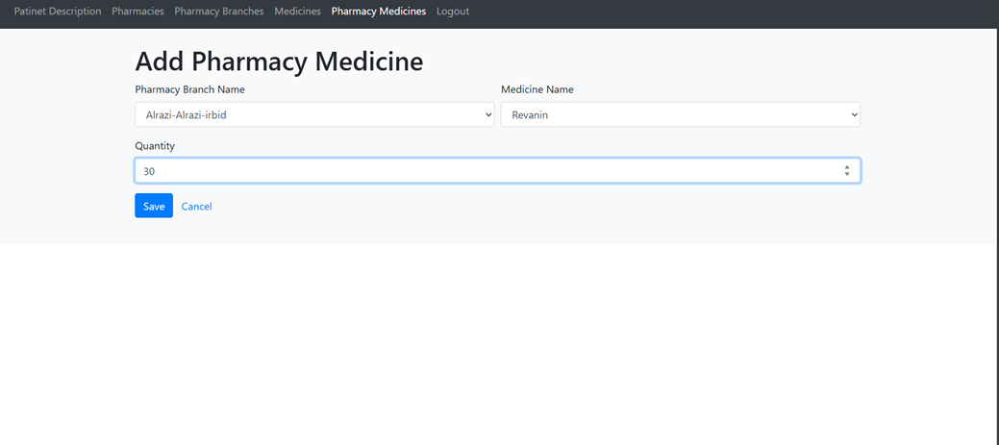

Figure 21: (Add Pharmacy Medicine)

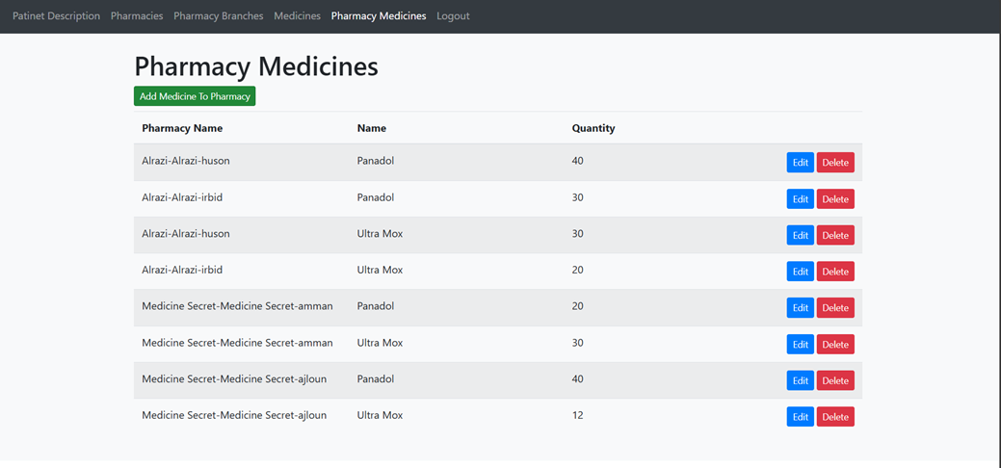

Figure 22: (Pharmacy Medicines)

3- Patient: This section shows how the patient interacts with the system, the patient can just view his description from view bottom and logout as show in figure 23, 24.

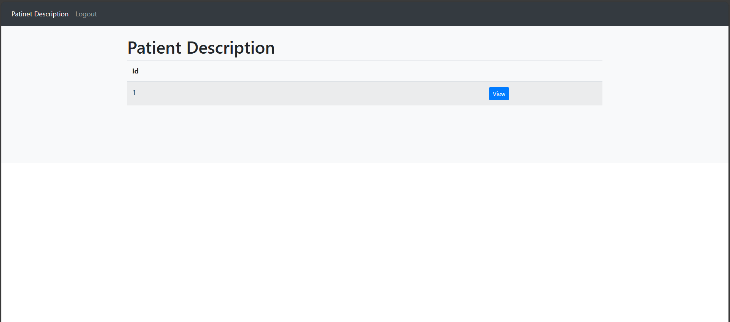

Figure 23: (Patient Description view)

Figure 24: (Patient Description Details)

* 1. Discuss the strengths and weaknesses of your solution/system.

Strengths of an E-Prescribing System:

1. Improved Medication Safety: When e-prescribing is used instead of traditional paper-based prescribing, medication mistakes can be considerably decreased. Automated drug interaction checks, allergy alarms, and dosage calculations are just a few of the features that assist medical professionals in making more precise and knowledgeable prescription decisions, which ultimately improves patient safety.

2. Increased Workflow and Efficiency: By allowing medical professionals to electronically communicate prescriptions to pharmacies from within the electronic health record (EHR) system, e-prescribing simplifies the prescription process. Prescribers and pharmacists can work more efficiently and reduce administrative expenses by doing away with the need for handwritten prescriptions, phone calls, and faxes.

3. Medication Adherence and Patient Engagement: By giving patients electronic prescriptions that are routed straight to their preferred pharmacy, e-prescribing systems can enhance medication adherence and patient engagement. Better medication adherence and health outcomes result from patients being able to conveniently refill medications online, receive automatic refill reminders, and access medication instructions and educational resources through patient portals.

Weaknesses of an E-Prescribing System:

1. Technical Difficulties and Dependability: Technology infrastructure, such as electronic health record (EHR) systems, pharmacy systems, and connection between pharmacies and healthcare providers, is a major component of e-prescribing systems. Technical problems can cause delays in medication administration and patient care by interfering with e-prescribing workflows. These concerns include system outages, software bugs, and connectivity issues.

2. Data Security and Privacy Issues: Sensitive patient data, such as pharmaceutical orders and medical histories, are transmitted electronically as part of e-prescribing. To maintain patient confidentiality and adhere to healthcare laws like the Health Insurance Portability and Accountability Act (HIPAA), it is imperative that the security and privacy of this data be guaranteed. The integrity and confidentiality of e-prescribing systems are seriously threatened by data breaches, illegal access, and cybersecurity threats; therefore, strong security measures and protections are needed to reduce any potential vulnerabilities.

3. User Acceptance and Training: Patients, pharmacists, and healthcare professionals must embrace and accept e-prescribing technologies for them to be implemented successfully. A few factors can inhibit the effective use of e-prescribing technology, including poor adoption rates, resistance to change, and unfamiliarity with electronic prescribing procedures and support. To promote the use of e-prescribing and optimize its advantages for patient care, healthcare institutions need to make investments in thorough training programs, intuitive user interfaces, and persistent support.

# Chapter 6: Economical, Ethic, and Contemporary Issues

* 1. Preliminary Cost Estimation and Justification

Cost Estimation:

- Development Tools: Free (Angular, MySQL, HTML, JS)

- Hosting: $0 (using free tier services)

- Maintenance: $0 (self-maintained)

Justification:

- Development Tools: Open-source, no cost.

-Hosting: Utilizing free hosting services.

- Maintenance: Self- maintained at no additional cost.

* 1. Relevant Codes of Ethics and Moral Frameworks

This website will make sure that information about individuals will be treated properly and equally, personal data will only be gathered for specified, accurate, and genuine reasons, also it will be sufficient and retained for no longer than is necessary.

* 1. Ethical Dilemmas and Justification of Proposed Solution

Every person will be notified about any further procedures that his or her personal data may be exposed to, such as making decisions, being corrected, deleted, or blocked, or being revealed to other third parties.

Any activities that violate the norms of personal data privacy will be handled with appropriate security measures.

* 1. Relevant Environmental Considerations

From an environmental point of view, there will be no harm to the environment by establishing this site. Since the site depends on practicing sports only, not making tools from nature or from this rejection, this will save environmental resources, and this is one of the positive features of the project.

* 1. Relevance to Jordan and Region (Social, Cultural, and Political)

The site will support all governorates of Jordan, and it is possible that I will later work on to develop it to include more areas. If we are lucky, our site will become available to all parts of the world.

# Chapter 7: Project Management

* 1. Schedule and Time Management of your project

The following table shows how the project was scheduled. From planning and research to implementation it took approximately 3 months to complete, and the specific dates are shown below.

|  |  |  |  |
| --- | --- | --- | --- |
|  | Start date | End date | Duration |
| Planning | 1/3/2024 | 10/3/2024 | 10 Days |
| Research | 15/3/2024 | 25/3/2024 | 10 Days |
| Design | 1/4/2024 | 20/4/2024 | 20 Days |
| Implementation | 23/4/2024 | 1/6/2024 | 5 Weeks |
| Follow up | 1/6/2024 | 20/6/2024 | 20 Days |

Table 9(Time Management)

* 1. Resource and Cost Management

Because this project is online, we didn't use any physical materials. Laptops and an internet connection were all that was required. The most valuable resource was the time spent learning how to create the website as designing and implementation and the timeline followed in the table above shows.

* 1. Quality Management

I ensured that when incorporating new functionalities or code blocks, I followed a rigorous testing process. This involved writing unit tests specifically tailored for the new additions, as well as conducting manual tests to assess their individual performance and how they seamlessly integrated with the overall application.

* 1. Risk Management

There are no risks for this type of project because it does not require the users to enter any private information about them, they only need internet access to browse the site. The site is very safe for users.

* 1. Project Procurement

The project might not need to buy anything. My project won't require outside resources for supplies or services.

# Chapter 8: Conclusion and Future Work

* 1. Summarize the main contributions of the work.

• Streamlined Prescription Process:

Designed a productive electronic prescription system that simplifies the prescription procedure for medical professionals. This expedites processing, guarantees accurate drug information, and lowers manual mistake rates.

• Technological Integration:

Angular for front-end development, Java for back-end functionality, HTML for web page structure, and MySQL for reliable database management were all successfully integrated. This technology combo offers a dependable, expandable, and user-friendly system.

• Improved Data Management:

Put in place a reliable and effective data management system that guarantees patient data integrity and confidentiality. Large datasets can be handled well, and information may be retrieved quickly when MySQL is used.

• User Interface and Experience:

Using Angular and HTML, an intuitive and responsive user interface was created, requiring little training for healthcare personnel to browse and operate the system.

* 1. Further future work someone should do to make the solution/system better.

• Integration with Other Healthcare Systems:

Make the system better by integrating it with other healthcare systems, like laboratory information systems, pharmacy management systems, and electronic health records (EHRs). This would enhance care coordination and offer a thorough view of patient data.

• Mobile Application Development:

Create a mobile app to supplement the web-based system, enabling medical professionals to view and control prescriptions while on the go. Flexibility and accessibility would rise as a result.

• Artificial Intelligence and Machine Learning:

Use AI and machine learning algorithms to offer early detection of probable drug interactions or contraindications, individualized medicine recommendations, and predictive analytics.

# References

**[1]:** Salmon JW, Jiang R. E-prescribing: history, issues, and potentials. Online J Public Health Inform. 2012;4(3):ojphi.v4i3.4304. doi: 10.5210/ojphi.v4i3.4304. Epub 2012 Dec 19. PMID: 23569654; PMCID: PMC3615836.

[2]: Donyai P, O'Grady K, Jacklin A, Barber N, Franklin BD. The effects of electronic prescribing on the quality of prescribing. British journal of clinical pharmacology. 2008 Feb;65(2):230-7.

[3]: Kaushal R, Kern LM, Barrón Y, Quaresimo J, Abramson EL. Electronic prescribing improves medication safety in community-based office practices. Journal of general internal medicine. 2010 Jun;25:530-6.

[4]: JavaScript with syntax for types. TypeScript. Available at:

<https://www.typescriptlang.org/> (Accessed: 08 May 2024).

[5]: For prescribers for prescribers. Available at: <https://www.digitalhealth.gov.au/healthcare-providers/initiatives-and-programs/electronic-prescribing/for-prescribers#ASL> (Accessed: 08 May 2024).

[6]: **What Is E-Prescribing and Why Is It Important?** [**https://www.businessnewsdaily.com/16468-what-is-eprescribing.html**](https://www.businessnewsdaily.com/16468-what-is-eprescribing.html)

[7]: Rangle.io : Angular training The Architect’s Guide to Angular. Available at: <https://angular-training-guide.rangle.io/architect>

(Accessed: 08 May 2024).

[8]: Inan, D.I. and Juita, R., 2011. Analysis and design complex and large data base using MySQL workbench. *AIRCC's International Journal of Computer Science and Information Technology*, pp.173-183.

[9]: Green, R.C., Wang, L. and Alam, M., 2013. Applications and trends of high performance computing for electric power systems: Focusing on smart grid. *IEEE Transactions on Smart Grid*, *4*(2), pp.922-931.